Fig 8 Caspase-1:

Fig 8 GSDMD-N: | 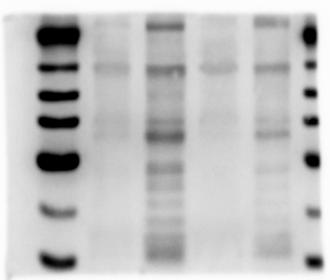
Fig 8 β-actin:

Fig 9 Bax: | 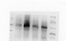
Fig 9 Bcl-2:

Fig 9 β-actin: | 